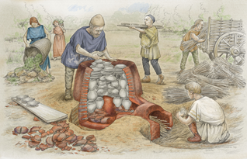
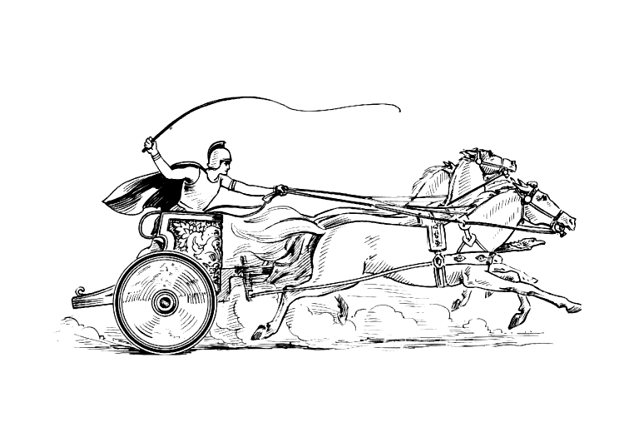

Gaius Attius Marinus - Mancetter Potter AD110-130
Minutes of the Annual Parish Meeting of the Parish of Mancetter

Minutes of the Mancetter Parish Annual Meeting of Parishioners held on Tuesday 23rd April, 2024, with the meeting opening at 7.00pm in the School Room, St. Peter’s Church, Mancetter.

Present:

Chairman: Trevor Hopkins.

Parish Councillors: Harold Blackburn; Glynis Forknall; Sue Healy; Peter Mann; John Tither; and Nicola Wallis.

Parish Clerk: Elane Higgins.

Borough Councillor: Denise Clews.

County Councillor: Margaret Bell.

Warwickshire Police: PCSO 6358 Charley Payne

Parishioners: Nine members of the public attended the meeting, in addition to those listed above.

Item 1. Welcome and Apologies.

The Chairman offered a warm welcome to all present at the Annual Parish Meeting for 2024.

Apologies were received from Keith Barnett (Borough Councillor), Caroline Foster, Jill Mawson, Andy Rothen, and Sharon Byard.

Item 2a: Minutes of the last meeting.

The minutes of the previous Annual Parish Meeting, held on Tuesday 23rd May, 2023, had been reviewed and were, therefore, signed formally at this meeting by the Chairman for the records.

Item 2b: Matters arising from minutes of the previous meeting.

All matters from the previous meeting had been dealt with.

Item 3: Borough and County Councillor Reports.

County Councillor Margaret Bell continues to be actively involved in raising highway concerns at County level, with a recent focus upon requests from Parish level for a pedestrian crossing to be provided between St. Peter’s Church and Gramer Cottages. This is in response to ongoing concerns about traffic levels and difficulties experienced by persons wishing to cross the road at that point in safety. Councillor Bell explained to those present at the meeting that the County Council has been unable to support a raised crossing on technical grounds and that a more formal crossing poses difficulties on grounds of cost versus the use such a crossing might get; however, Councillor Bell explained how she is seeking to challenge this approach and is fighting to make provision of a safe crossing a special case. Councillor Bell’s continued active support, again at County level, for the restoration of land at the Mancetter Quarry site in the near future, when operations at the quarry cease. Further, the poor condition of the major traffic island on the A5, at the junction with Harper’s Lane was raised by some parishioners, including the Chairman, and Councillor Bell again has raised this issue with County and National Highways.

Representing the Borough Council was Borough Councillor Denise Clews. (Borough Councillor Keith Barnett had been unable to attend due to meeting commitments at Borough Council level). Councillor Clews explained the levels of active support that continue to be offered to members of the Parish (both in Mancetter and Ridge Lane) who have experienced difficulties due to the current economic situation, nationally and locally. Such support was also linked to work with local community groups and various projects associated with them. Further provision of Defibrillation machines and Blood Packs, with associated training for volunteers, was also outlined.

Item 4: Chairman’s Report. *

The Chairman, Mr. T. Hopkins, delivered his annual report for the year 2023/2024, as Chair of Mancetter Parish Council. A copy of the report was displayed to all present at the meeting and a copy will be published on the Parish Council Website. A copy of this report to read in full is also available upon request in the Parish Council Office within Mancetter Memorial Hall.

The Chairman’s report highlighted a number of challenges faced by the Parish Council over the past year. These included the unforeseen collapse of a tree on the village green area, which caused some damage to a vehicle parked nearby. An ongoing challenge centres upon issues with increasing traffic flow thorough Mancetter, in particular, and incidents of speeding vehicles as monitored and recorded by the volunteer Speed Watch body. Issues relating to problems with the junction of Woodford Lane and the A5 Watling Street featured again following a meeting between a delegation from the Parish Council and the Member of Parliament for North Warwickshire. Other traffic related issues involving HGV’s using Steppey Lane were highlighted with references made to positive solutions being sought by the Parish Council, local HGV operators, Mancetter Quarry and the County Council.

Recognition was given to Karen Meads, who retired this past year, for her contribution to the work of the Parish Council. Appreciation was recorded by the Chairman to the current Parish Clerk to the Council, Mrs Elane Higgins, for her ongoing work to maintain and improve further the efficient working of the Council. The valuable contributions made by local contractors to the Parish, namely Messrs. Rob Drakeford, Barry Stevenson and John Thompson were highlighted, too.

Item 5: Finance Report. *
Clerk to the Council, Mrs. E Higgins, acting in her capacity as Responsible Finance Officer to the Parish Council, delivered the financial report. A Copy was displayed to all persons present at the meeting. A copy of this report to read in full is available upon request in the Parish Council Office within Mancetter Memorial Hall and uploaded to the website.
Reference was made to the sources of income that funds the work of the Parish Council. Once again, the Finance Report highlights the responsible approach taken by the Parish Council when ensuring that public funds are used both prudently and effectively.

Item 6: Warwickshire Constabulary Report.
PCSO 6358 Charley Payne was introduced to all present at the meeting. A summary of local incidents to which the local Warwickshire Police SNT team responded between 22nd March and 20th April, 2024, was distributed amongst all those present at the meeting. The summary of incidents was prepared by PC 609 Hoey.

Item 7: Save Our EARTH Presentation:
Chairman Trevor Hopkins, making use of a power-point presentation, explained how the Parish Council continues to develop a vision and formulate plans with regards to the restoration to nature of Mancetter Quarry as operations there are destined to cease over the next few years. The Parish Council continues to press and work in a constructive way with both the current owners of Mancetter Quarry and the County Council in this matter. With references made to the Parish Neighbourhood plan, Mr Hopkins identified the unique nature of Mancetter Parish within the wider area of North Warwickshire, as created by a long period of quarrying and coal mining. The vision outlined showed how careful restoration could enable all concerned to make a significant contribution locally towards reversing the damage done to the environment over time. The restoration of woodland planted with native species could help to restore much of the biodiversity surrounding flora, fauna, and wildlife. In addition, the health benefits to people, from near and afar, of creating safe areas for walking and cycling, together with benefits for businesses and tourism in creating local employment, make this project an essential part of the future for Mancetter Parish.

Item 8: Reports from the Roman Mancetter Exhibition and Ridge Lane Groups.
I) A representative of the Roman Mancetter Exhibition, which is located within St. Peter’s Church, reported that the project continues to develop well, having opened to the public on twenty-seven Saturdays over the past year, with 1,800 visitors attending. The volunteer group who present the exhibition have worked with local Primary school parties, from which pupils’ have enjoyed dressing as a Roman soldier amongst other activities. Feedback from the schools and their pupils has been
excellent. The exhibition was an important feature in the Atherstone Historical Festival and received a further two hundred and fifty visitors as a result. It was announced that plans are in place to expand further still throughout 2024 -2025, with support from NWBC. All present at the meeting passed on their thanks to all volunteers for their involvement and enthusiasm.

ii) The Reverend Linda Mudd reported on behalf of St. Peter’s Church and the work carried out in support of the local community, examples of which related to the Parent support group and the provision of breakfast clubs for local people during the school holidays. Linda remains dedicated to engaging further with the local community.

iii) No official representation was available with regards to the Gramer Cottages, but with two residents at the meeting it was reported that all is well with the occupants of the property. Some discussion was had regarding the ironwork canopy which was removed in recent years. The canopy remains on the premises, but in a disassembled state. The desired restoration of the canopy has proven to be difficult at the present time because of the costs involved.

iv) It was reported that the Memorial Hall remains accessible to all within the Parish and continues to be managed by volunteers. Good use continues to be made of the facilities offered at the hall, with several community groups from across the age spectrum enjoying fitness classes, ‘Tea and Chat’ sessions, and bingo sessions. The Rainbow group, Brownies and Guides have made good use of the hall, especially for ‘Sleep-Over’ sessions. The hall has also provided a base for groups offering advice and support for people affected by the current economic situation.

v) A representative from Mancetter W.I. gave a brief report on the group’s activities over the past year, which have included outings, talks by visiting speakers and plans for a charity fashion show. The membership of the W.I. currently stands at fourteen.

vi) Activities based at Ridge Lane Community Hall continue to thrive. A programme of visiting speakers has been well received, together with community activities such as the Christmas Fair, celebrations of the late Queen’s jubilee, the community cafe, and regular ‘Tea and Toast’ sessions so important to those residents who live alone. The Youth Group is recovering from the Covid period with a number of six to thirteen year olds participating in a range of activities on Tuesday evenings, between 6.00 -7.30 pm.

vii) The Chairman reported that the allotments, located in Ridge Lane but accessible to anyone within the wider Parish, has recovered well post-Covid. All plots are currently let.

viii) Invitations to attend the Parish Meeting were extended to Little Stars Nursery, Mancetter Scout Group and the Neighbourhood Watch (Jill Mawson sent apologies). Whilst no official representation was present from these bodies the Parish Clerk was able to report that the Little Stars Nursery was continuing to prosper under the leadership of a new manager.

Item 9: AOB
The Mancetter Speed Watch continues to operate on a volunteer basis. Details about how the group operates were provided and a call for more volunteers to participate in the ‘Watch’ was made. The continued need for this group was underlined by the report from the latest ‘meeting’ which registered nine hundred and fifty three vehicles passing through the village in one single hour of operation, and with a speed of 45mph being recorded for one particular vehicle. Mancetter has a 30mph speed limit.

The Parish Council complement is normally eight councillors. Currently, seven councillors sit on the Council with one further position vacant. Any person interested in filling this vacancy should contact the Parish Clerk for further details.

The meeting was closed, formally, by Mr T Hopkins following the completion of all business. All attendees were thanked for their support.

